📄 PAGE 1 (Cover)

Amazon Delivery Analytics Report
Prepared by: Abdulla Kazimli
Project Type: End-to-End Data Analytics Project
Tools Used: Python, SQL, Power BI, Machine Learning
Dataset: Amazon Delivery Dataset
Year: 2026

📄 PAGE 2 (Contents)

Table of Contents
- Executive Summary
- Business Problem
- Dataset Overview
- Data Cleaning & Preprocessing
- Exploratory Data Analysis (EDA)
- Statistical Analysis
- Machine Learning
- Business Recommendations
- Conclusion

📄 1. Executive Summary
This project presents a comprehensive end-to-end analysis of Amazon delivery operations using real-world logistics data. The objective was to identify the operational and environmental factors affecting delivery performance and provide data-driven recommendations to improve efficiency.
The analysis integrates multiple stages of the modern data analytics workflow, including SQL querying, exploratory data analysis (EDA), statistical hypothesis testing, predictive machine learning, and interactive Power BI dashboards.
More than 43,000 delivery records containing operational, geographical, temporal, and environmental information were analyzed. The dataset includes delivery agent characteristics, traffic conditions, weather, vehicle type, delivery distance, order time, preparation time, and final delivery duration.
The project follows a complete analytical lifecycle:
• Data collection
• Data cleaning
• Feature engineering
• Exploratory Data Analysis
• Statistical Analysis
• Machine Learning
• Business Intelligence Dashboard Development
• Business Recommendations
The final result provides actionable insights for improving operational efficiency and delivery performance.

📄 2. Business Problem
Amazon processes thousands of deliveries every day. Delivery delays negatively affect customer satisfaction, operational efficiency, and logistics costs.
The objective of this project is to identify the key operational factors influencing delivery time and develop data-driven recommendations for improving delivery performance.
The analysis focuses on answering the following business questions:
• Which factors have the strongest impact on delivery time?
• How does traffic affect delivery performance?
• Does weather significantly increase delivery duration?
• Which vehicle type performs best?
• During which hours are deliveries the slowest?
• Which weekdays experience the highest delivery time?
• Can machine learning accurately predict delivery duration?

📄 3. Dataset Overview
Dataset Name: Amazon Delivery Dataset
Total Records: 43,492
Target Variable:
• Delivery_Time
Main Features:
• Agent Age
• Agent Rating
• Weather
• Traffic
• Vehicle
• Area
• Category
• Order Hour
• Preparation Time
• Distance (km)
The dataset contains operational, geographical, and temporal information collected from Amazon delivery operations.

📄 4. Data Cleaning & Preprocessing
The dataset required several preprocessing steps before performing statistical analysis and machine learning.
The following operations were completed:
• Missing values analysis
• Removal of inconsistent values
• Date conversion
• Time conversion
• Feature engineering
• Order Hour extraction
• Weekday extraction
• Month extraction
• Distance calculation using latitude and longitude
• Preparation Time calculation
• Label Encoding for categorical variables
The cleaned dataset was then used for all subsequent analyses.

📄 5. Exploratory Data Analysis (EDA)
Exploratory analysis was performed to better understand delivery behavior.
The following analyses were completed:
• Distribution of Delivery Time
• Delivery Time by Traffic
• Delivery Time by Weather
• Delivery Time by Vehicle
• Delivery Time by Area
• Delivery Time by Category
• Delivery Time by Hour
• Delivery Time by Weekday
• Correlation Heatmap
• Feature Relationships
The visualizations identified several important operational patterns affecting delivery performance.

5.1 Delivery Time by Traffic
Traffic conditions are one of the most influential factors affecting delivery performance. The visualization below demonstrates how delivery duration changes under different traffic conditions.
The distribution indicates that deliveries performed during traffic jams require significantly more time than deliveries completed under low traffic conditions. Additionally, higher traffic levels are associated with greater variability in delivery duration.

Key Insight
- Heavy traffic substantially increases delivery time.
- Peak-hour traffic should be considered when planning delivery routes.

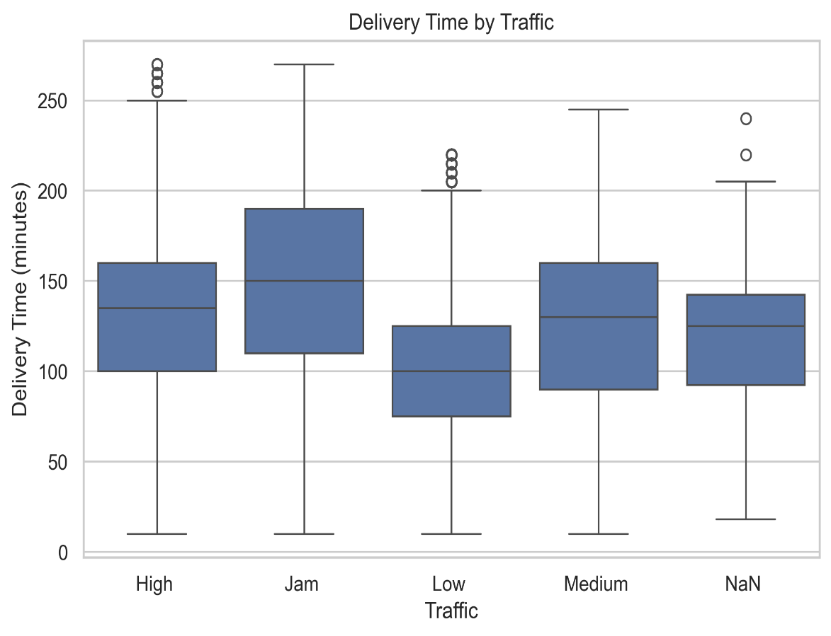

5.2 Delivery Time by Weather

Weather conditions play an important role in delivery efficiency. Adverse weather can slow transportation, increase travel uncertainty, and extend delivery duration.
The visualization below compares delivery times under different weather conditions. The results indicate that extreme weather, such as storms and sandstorms, generally leads to longer delivery durations compared to normal weather conditions. This highlights the importance of considering weather forecasts when planning delivery operations.
Key Insight
- Severe weather conditions increase delivery time.
- Extreme weather leads to higher delivery variability.
- Delivery planning should consider weather forecasts to improve operational efficiency.
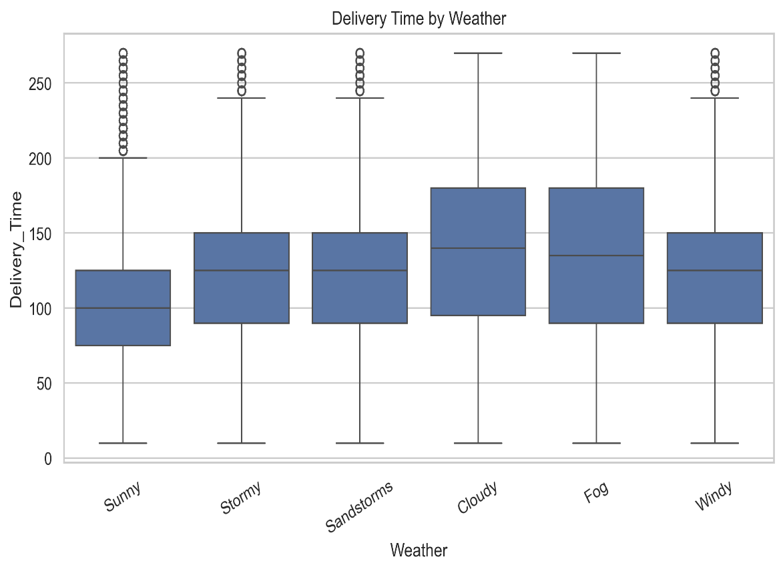

5.3 Order Distribution by Hour
Customer ordering behavior varies throughout the day, creating distinct demand patterns that directly influence delivery operations and resource allocation.
The visualization below presents the distribution of customer orders by hour. The results indicate that demand is concentrated during the evening hours, while significantly fewer orders are placed during the late night and early morning. Understanding these patterns helps optimize courier scheduling and workforce planning.
Key Insight
- Order demand peaks during the evening hours.
- Lower demand occurs during late-night and early-morning periods.
- Workforce allocation should be adjusted according to hourly demand patterns.
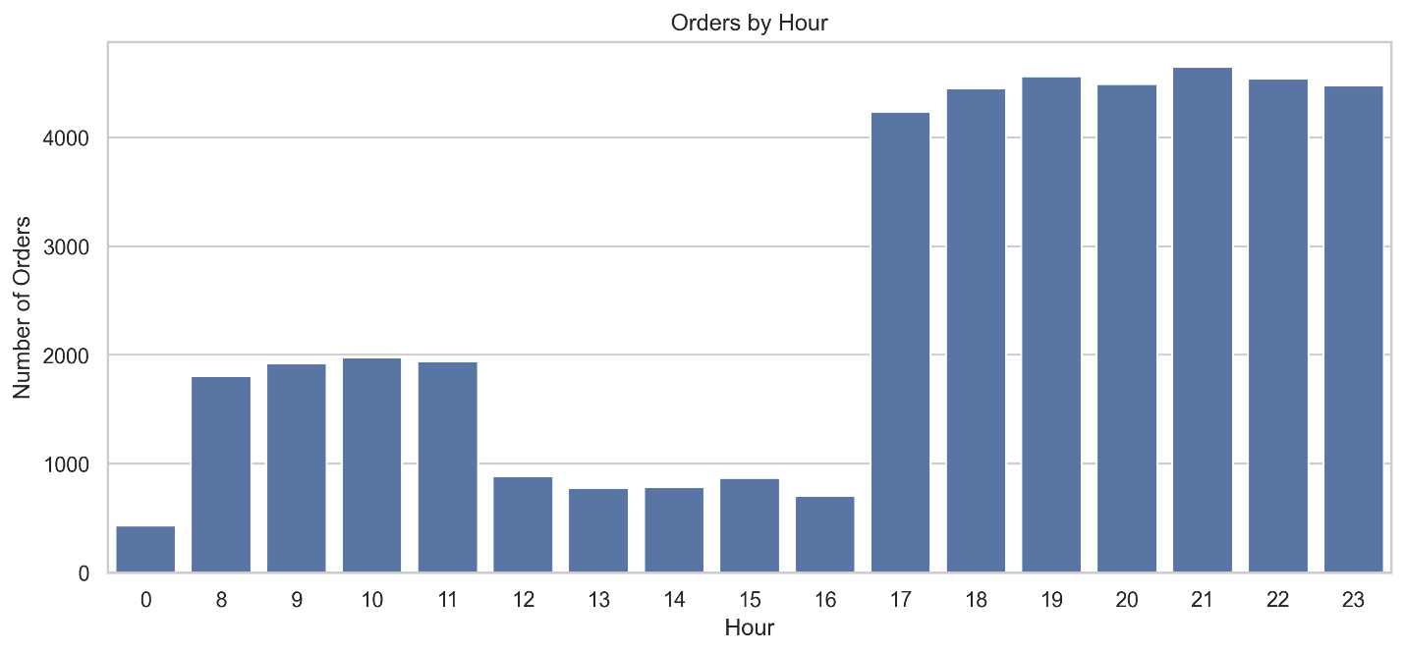

5.4 Correlation Analysis
Correlation analysis was performed to examine the relationships between numerical variables included in the dataset. Understanding these relationships helps identify the strongest predictors of delivery time and supports subsequent machine learning modeling.
The correlation heatmap highlights several meaningful relationships among the variables. Delivery distance and traffic conditions exhibit positive correlations with delivery time, indicating that longer travel distances and heavier traffic generally lead to increased delivery duration. Other variables demonstrate weaker correlations, suggesting a more limited influence on delivery performance.
Key Insight
- Delivery distance shows a positive relationship with delivery time.
- Traffic conditions are among the strongest operational factors affecting delivery performance.
- Correlation analysis supports the selection of features used in predictive modeling.
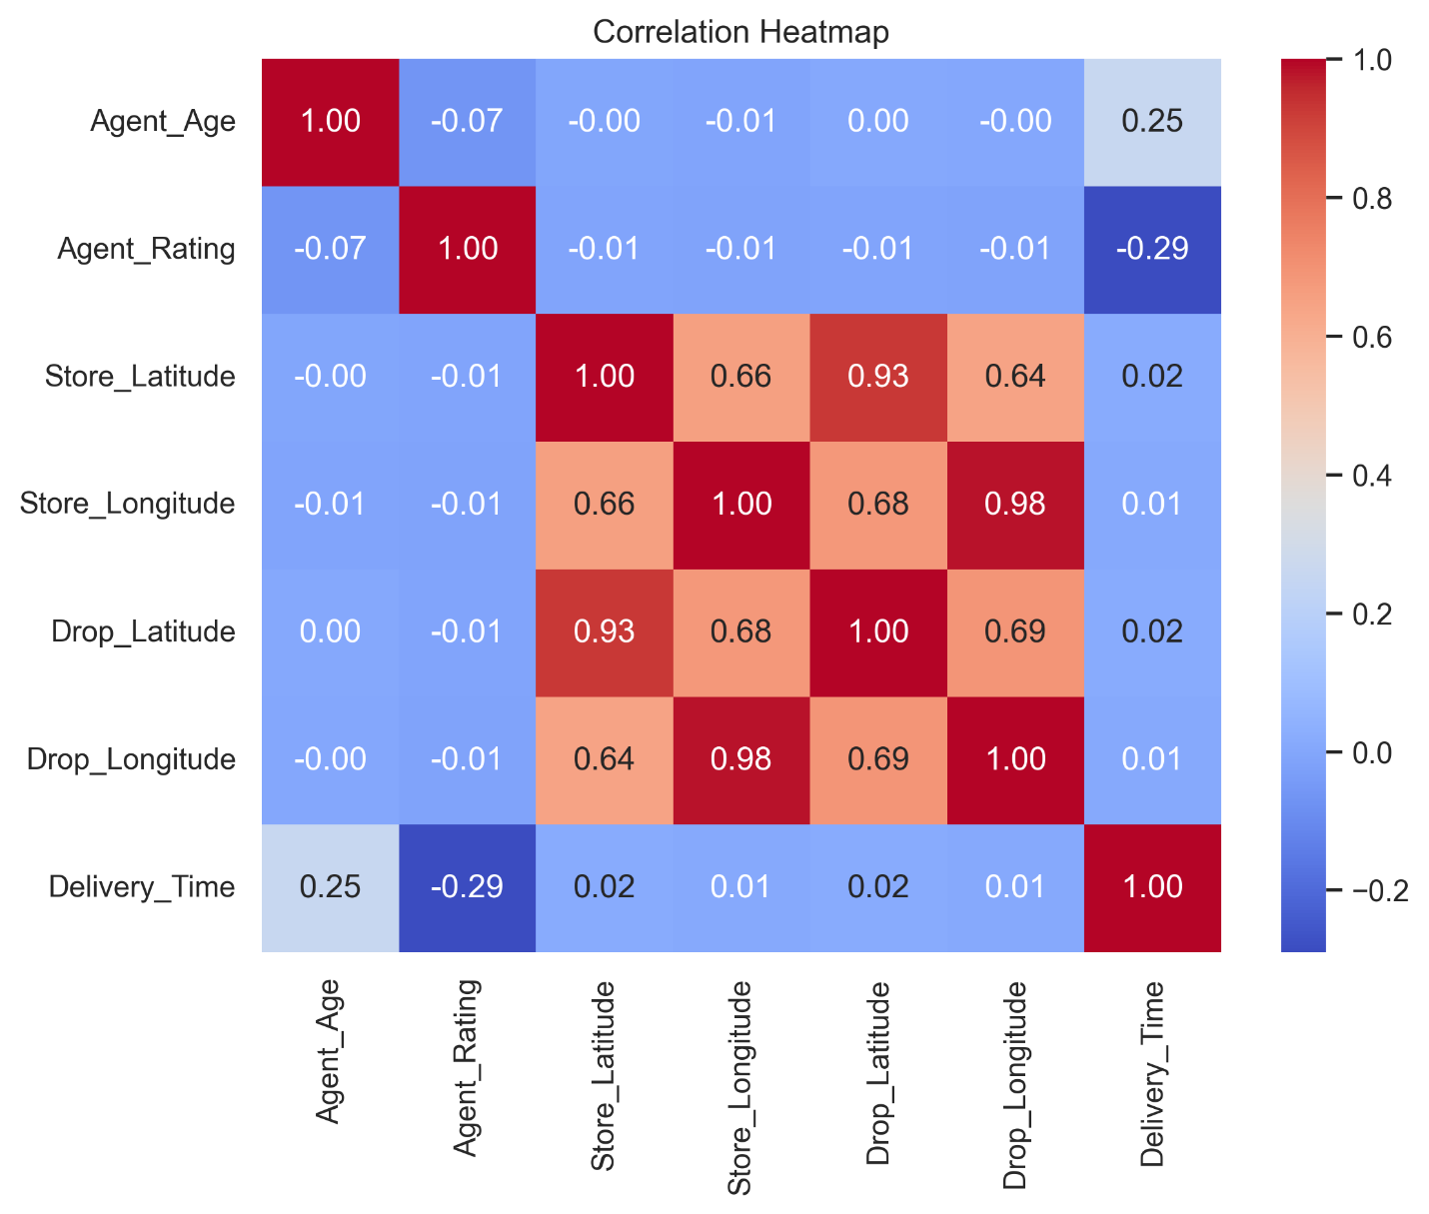

5.5 Feature Importance
Feature importance analysis was performed using the Random Forest Regressor model to identify which variables contribute most to predicting delivery time.
The results indicate that Order Category, Agent Rating, Weather, and Delivery Distance are the most influential predictors. Variables such as Preparation Time and Area have relatively low importance, suggesting a smaller contribution to model performance.
Understanding feature importance helps logistics managers focus on the operational factors that have the greatest impact on delivery efficiency.
Key Insight
- Order Category is the most important predictor of delivery time.
- Agent Rating and Weather conditions strongly influence delivery performance.
- Delivery Distance remains one of the key operational factors.
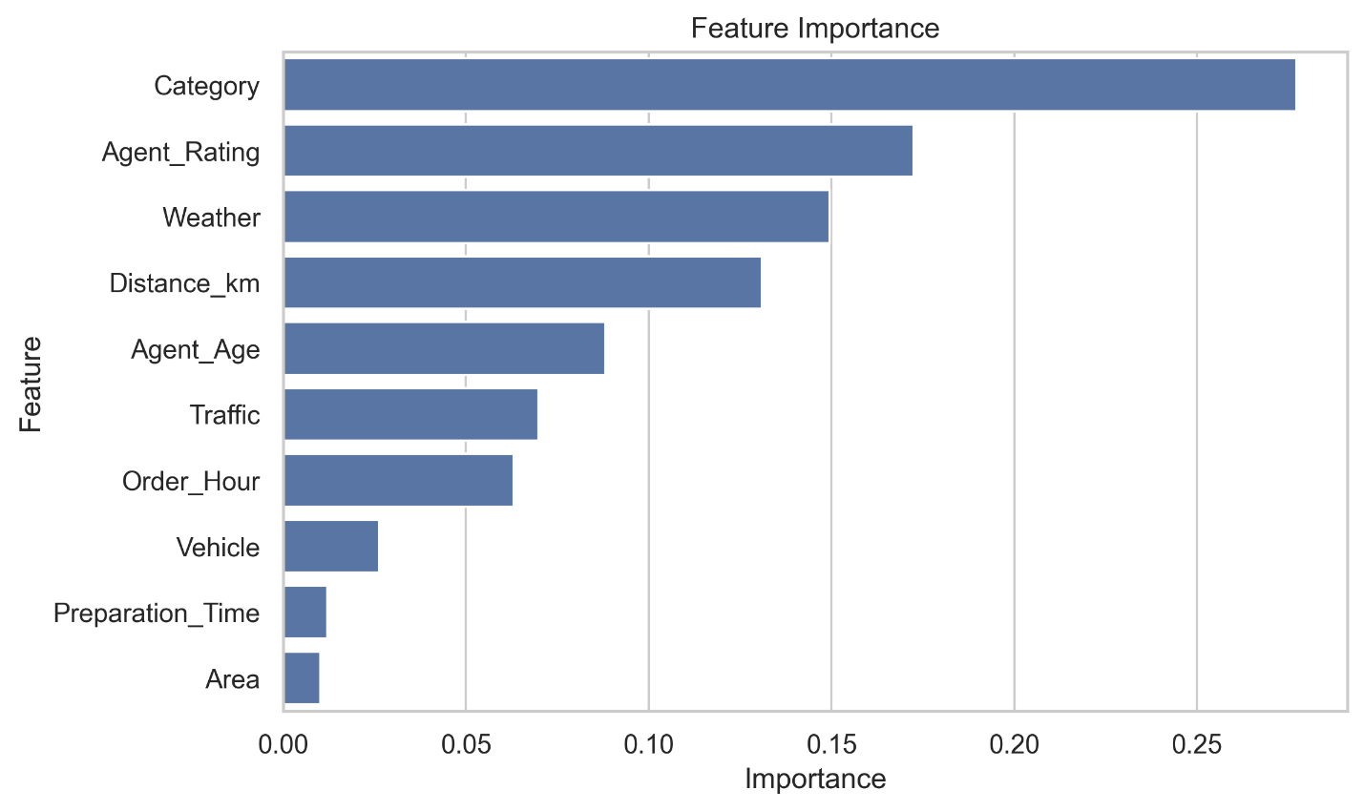

5.6 Model Comparison
To evaluate predictive performance, two machine learning algorithms were developed and compared: Linear Regression and Random Forest Regressor.
Model performance was assessed using R² Score, Mean Absolute Error (MAE), and Root Mean Squared Error (RMSE). The comparison demonstrates that the Random Forest model substantially outperformed Linear Regression across all evaluation metrics.
This result suggests that delivery time depends on complex, non-linear relationships between operational variables, making ensemble tree-based methods more suitable for prediction.
Key Insight
- Random Forest achieved significantly higher predictive accuracy.
- Linear Regression was unable to capture complex relationships within the data.
- Random Forest is recommended for delivery time prediction.
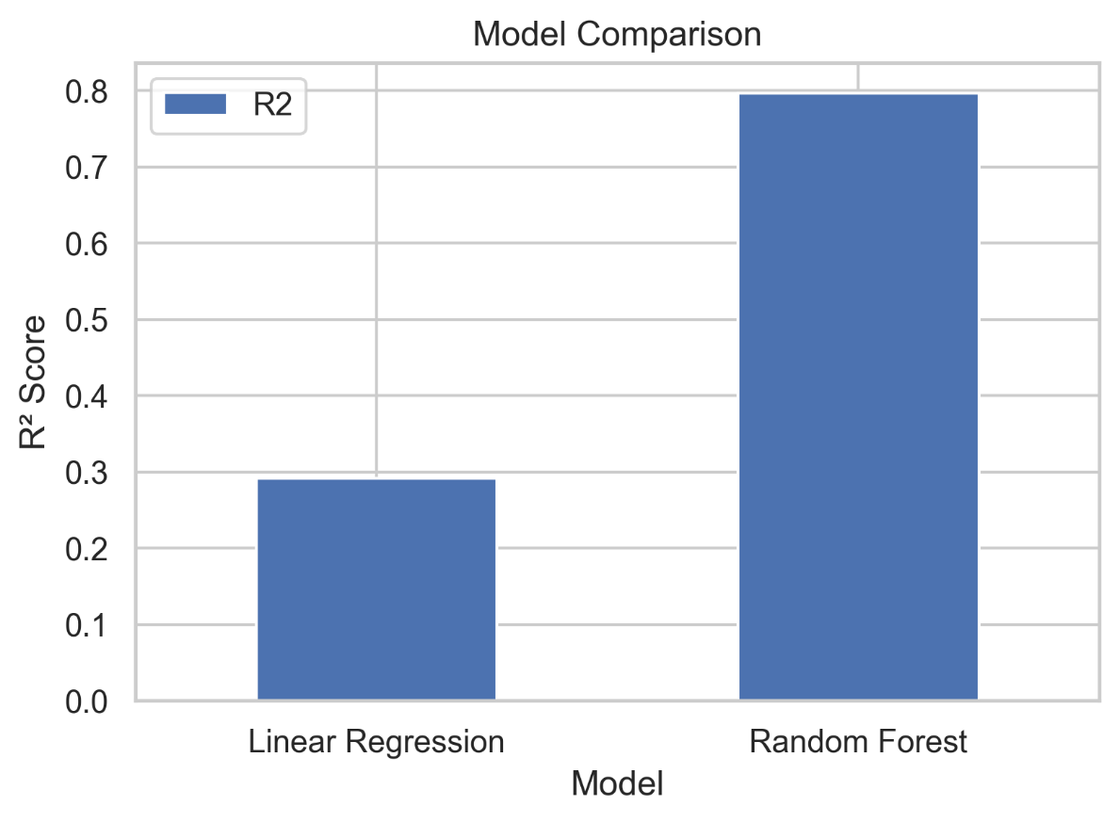

📄 6. Statistical Analysis
To verify whether observed differences were statistically significant, one-way ANOVA tests were performed.
The following hypotheses were tested:
Traffic → Delivery Time
Weather → Delivery Time
Vehicle Type → Delivery Time
Results:
Traffic showed a statistically significant effect on delivery time (p < 0.05).
Weather also demonstrated statistically significant differences in delivery duration.
Vehicle type significantly influenced delivery performance.
These findings confirmed that delivery duration is strongly affected by operational and environmental conditions.

📄 7. Machine Learning
Two regression models were developed to predict delivery time.
Models:
• Linear Regression
• Random Forest Regressor
Evaluation Metrics:
• R² Score
• Mean Absolute Error (MAE)
• Root Mean Squared Error (RMSE)
Random Forest substantially outperformed Linear Regression across all evaluation metrics, indicating that delivery performance depends on complex nonlinear relationships between operational variables.
Feature Importance analysis identified the most influential predictors of delivery time.

📄 8. Business Recommendations
Based on the analysis, the following recommendations are proposed:
• Improve route optimization during heavy traffic periods.
• Increase delivery resources during peak operational hours.
• Prepare contingency plans for adverse weather conditions.
• Prioritize high-performing vehicle types where possible.
• Monitor low-rated delivery agents and provide additional training.
• Use predictive machine learning models to estimate delivery duration before dispatch.
• Continuously monitor operational KPIs using Power BI dashboards.
These recommendations can improve delivery efficiency and customer satisfaction.

📄 9. Conclusion
This project demonstrates a complete end-to-end data analytics workflow using SQL, Python, Power BI, statistical analysis, and machine learning.
The analysis identified several operational factors that significantly influence delivery performance, including traffic, weather, vehicle type, delivery distance, and preparation time.
The Random Forest model achieved the best predictive performance and can be used to estimate delivery duration with high accuracy.
Overall, this project demonstrates the complete workflow of a Data Analyst, from data preparation and exploratory analysis to statistical testing, predictive modeling, dashboard development, and business recommendations. The insights generated can support data-driven decision-making and contribute to improved logistics performance and customer satisfaction.

